
u|Lg ;f];fO6L klAns :s'n
/Tggu/–&, ;f}/fxf lrtjg
t];|f] q}dfl;s परीक्षा—@)*@
sIff M– o'=s]=hL समय - @ 3+= k"0ff{ÍM–%) ljifoM–g]kfnL
gfd : ====================================================/f]n g+=============;]S;g M ================
_________________________ ______________________ s'n k|fKtfÍ :
lg/LIfssf] ;xL k/LIfssf] ;xL

k|Zg g+= ! k|Zg g+= ! …dfqf nufP/ n]Vg'xf];\ . -#_
s ± f Ö 5 ± ] Ö
v ± ' Ö h ± " Ö
r ± l Ö u ± F Ö
k|Zg g+= # rGb|ljGb' - F _ nfu]sf zAbx¿ n]Vg'xf];\ . -#_

k|Zg g+= $ cf]sf/ -f]_ dfqf nfu]sf zAbx¿ n]Vg'xf];\ . -#_

k|Zg g+= $ k|Zgsf] pQ/ lbg'xf];\ . -#_
s_ tkfO{+sf] gfd s] xf] <
d]/f] gfd xf] .
v_ tkfO{ slt aif{sf] x'g'eof] <
d aif{sf] ePF .
u_ tkfO{+slt sIfdf k9\g'x'G5 <
d sIff k9\5' .
k|Zg g+= % ;'?sf] cIf/df lz/ljGb' nufpg'xf];\ . -%_
ruf buf /u x; cu'/
k|Zg g+= ^ j0f{ hf]8]/ zAb agfpg'xf];\ . -%_
d" uf{
j vf{
b' iff{
s' lt{
r ;L{

k|Zg g+= & lbOPsf] ;d"xjf6 nofTds gePsf zAbx?nfO{ s|; lrGx nufpg'xf];\ . -%_
hbf} bf}/f
ebf}
rf}w sf}jf
6f}jf
sf};L df}/L
cf};L

gf}nf] sf}8L
kf}8L
nf}sf gf}sf
sf}jf

k|Zg g+= * zAb hf]8]/ jfSo agfpg'xf];\ . -%_
lsg nufpm /fv
af]s agfpm
sf]6 emf]nf rf]nf] uf]nf] 6f]s/L

k|Zg g+= ( afx|v/L k"/f ug'{xf];\ . -^_
pbfx/0fM–s sf ls sL s' s" s] s} sf] sf} s+ sM
r

k|Zg g+= !) v'6\6f sf6]sf zAbdf dfq uf]nf] 3]/f nufpg'xf];\ . -^_
k|yd wf]s|f] cf]7
s]/fp h'd|f
k|;fb r+uf u|x
r}t af]s|f

k|Zg g+= !! lrqx]/L gfd n]Vg'xf];\ . -^_
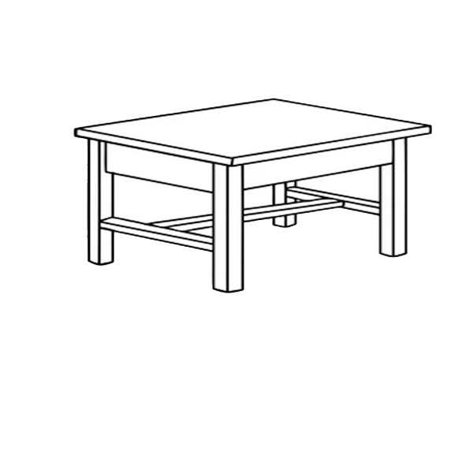 | 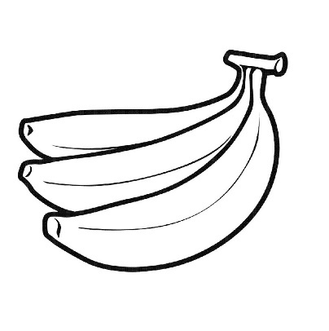 | 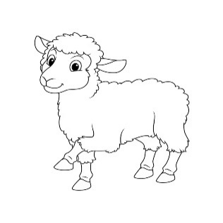
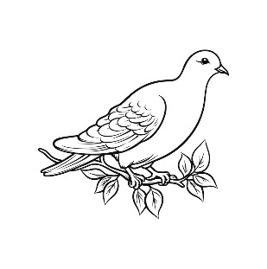 | 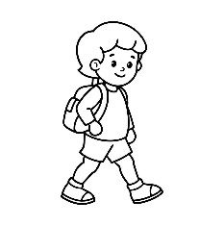 | 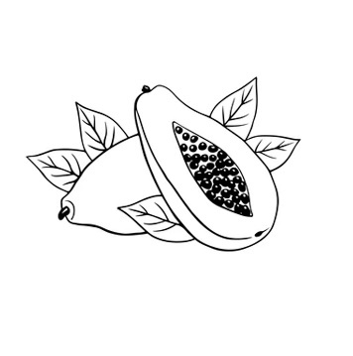
;dfKt

